A Boat Trip Along the Danube River

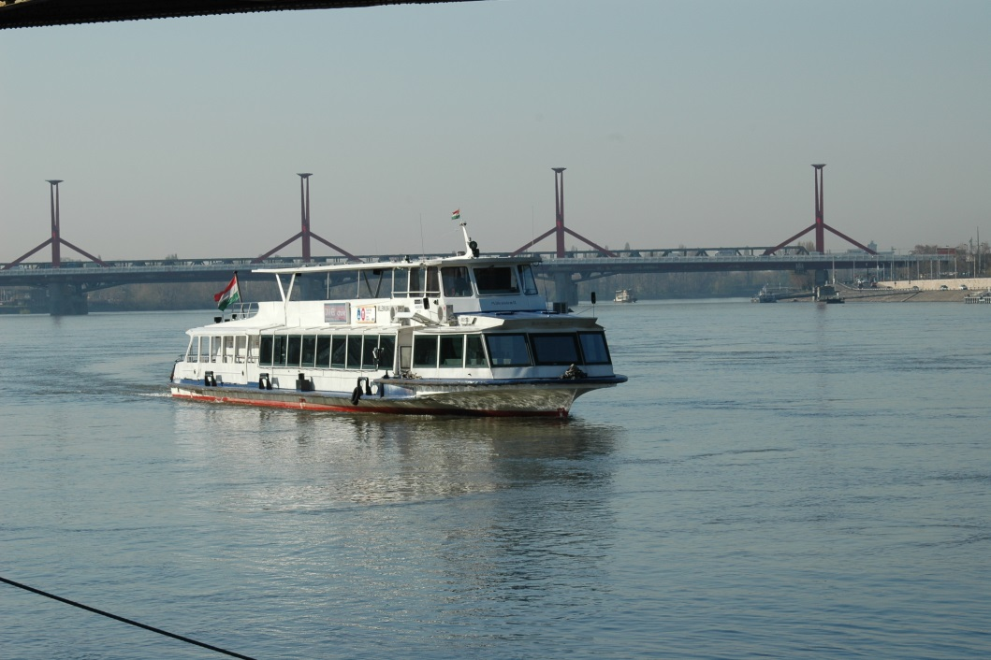
We started our trip from Boraros Square at eight o'clock in the morning. Most of us were still tired because we got up very early and went to our meeting point in Boraros Square.
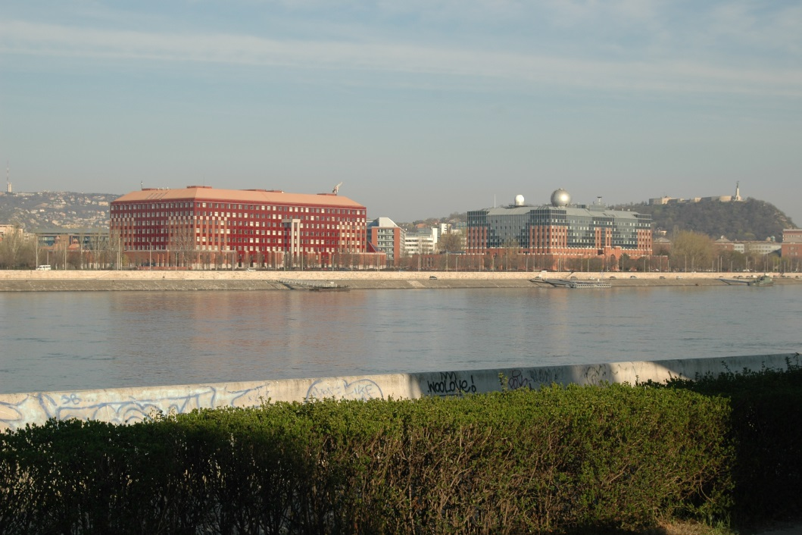
As we had a little time before our ship arrived, we took a suburban train and visited the Palace of Arts and the National Theatre.

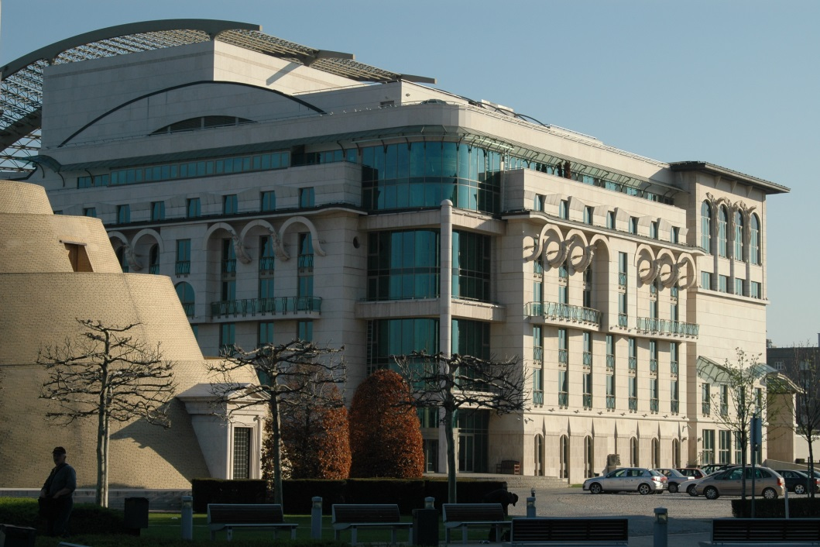
Then we went back and got on the BKV boat, which is the public transport boat. At first, we were disappointed because there was only one passenger on the boat besides the eight of us.
First of all, we enjoyed the view and took lots of pictures of both sides of Budapest (Budapest is separated by the Danube into two parts - Buda and Pest).
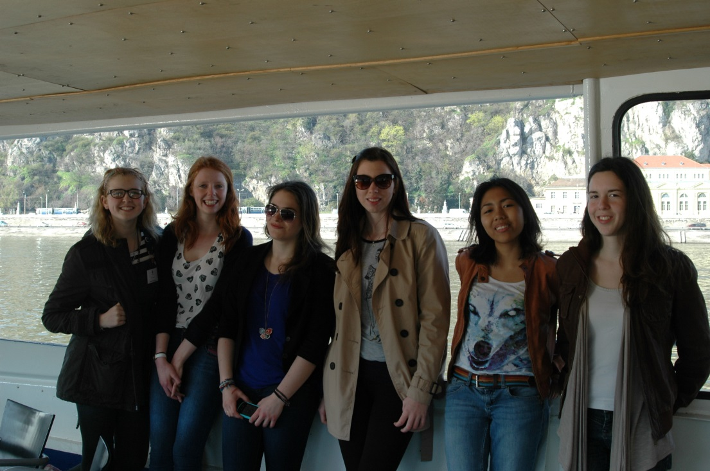
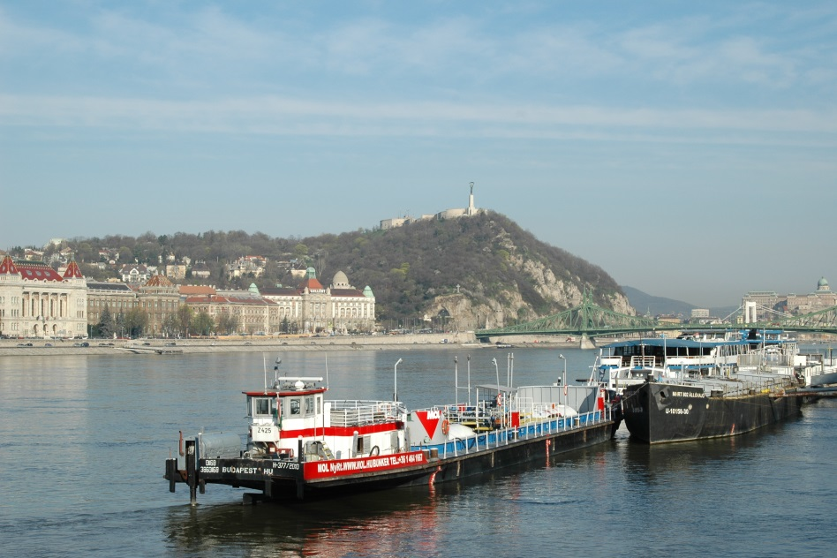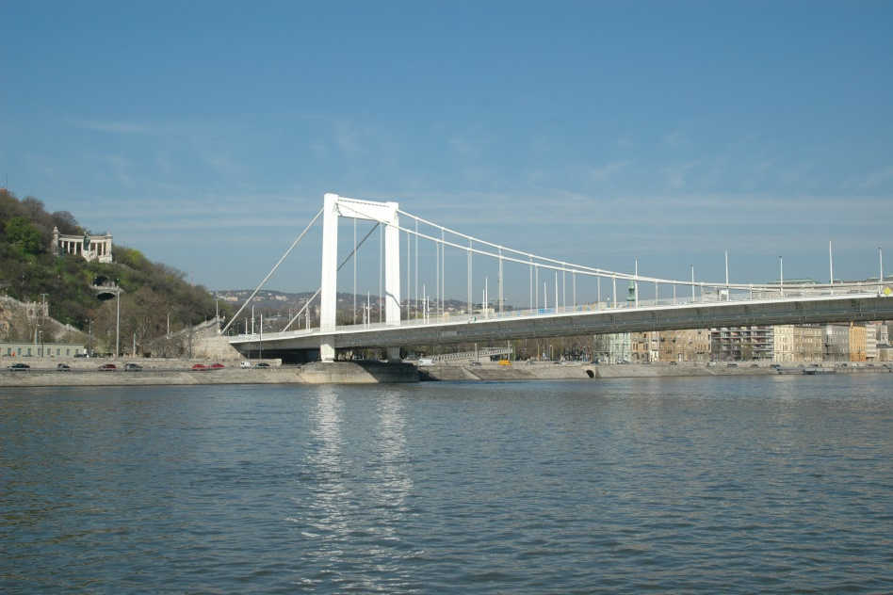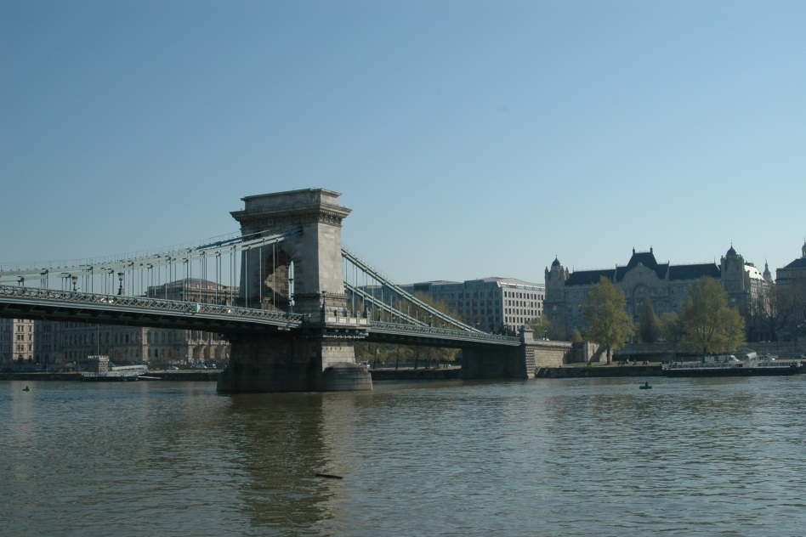
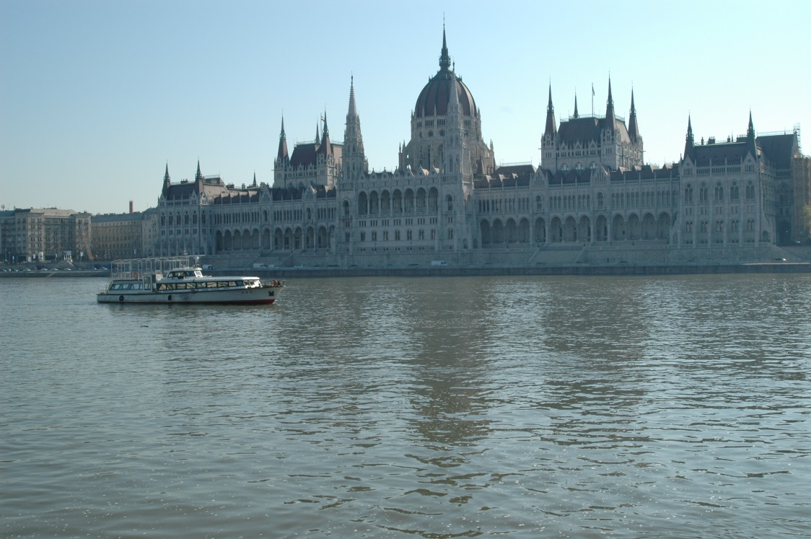
Then we interviewed the only other passenger on board. He was a man from Hungary, he uses the facility twice a week but only in summer time to go to work. He said the boat is not faster than the other public transport vehicles but this way he has the opportunity to enjoy the weather and the view of the city. It takes him half an hour to get to his destination, to Batthyany Street. He also told us that he was satisfied with the quality of the service on the boat because there is no mess and it is not crowded. He has even rented a boat for an event with fifteen of his foreign friends and they had really a good time.
Fifteen minutes later after the man reached his destination, a group of three people got on the boat at Jaszai Mari Square. They came from Israel. One of the women has a Hungarian husband but now they live in Israel. She said that even though they visit Budapest three or four times a year it was their first time to have a trip by boat along the Danube. So far, they seem to like it very much because they could enjoy the weather and the view Budapest offers.
We interviewed not only passengers but also the crew on the boat. They told us that in the afternoon BKV is used by kindergarten and school groups. They informed that us most of passengers are not only teenagers but also adults.
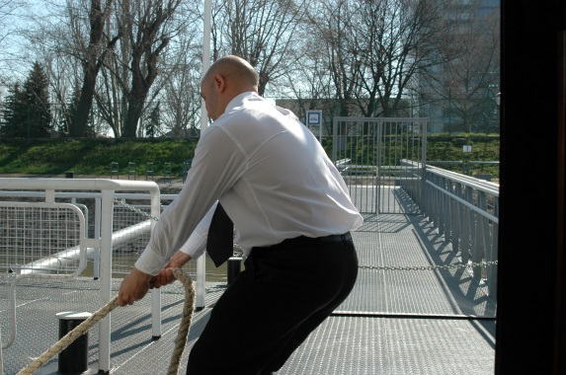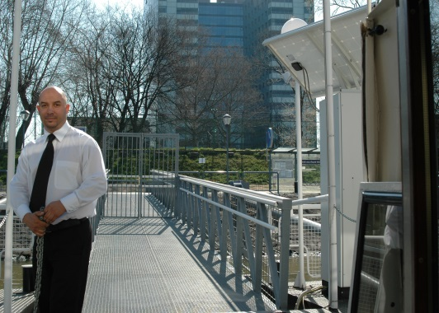
They operate the whole year but in spring and summer when the weather gets warmer they have more passenger compared to the seasons when the weather gets wet and cold.
After this observation, we came to the conclusion that, either we were too early in the morning for a boat trip or the locals do not use this facility due to the fact that it takes a long time to reach their destination. But we recommend that tourists should put this trip on the Danube on their to-do-list when they are in Hungary! You have the best view of both Buda and Pest side if you take the boat from Boraros Square to Napfürdő Street and it costs only 450 Ft/person. If you have a season ticket you can use it for free (also buses, trams, and underground)
To put it in a nutshell we enjoyed our trip because we got to see the best views of the city and enjoyed the nice weather as well.
Ruff Bettina, Wachsler Ágnes és Szathmári Eszter

New bridges:
Megyeri Bridge (2008)
length: 1862 m
width: 35 m
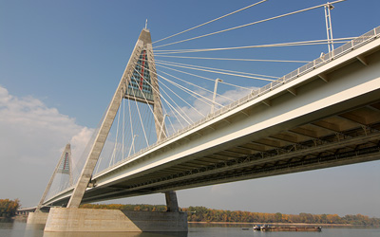
Lágymányosi Bridge (1995)
length: 494 m
width: 30,5 m
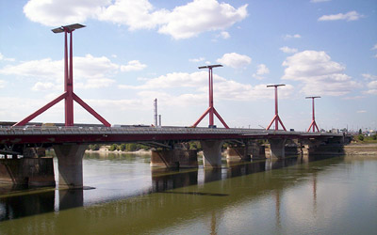
Historical bridges:
Arpad Bridge (1939)
length: 981 m
width: 27,6 m
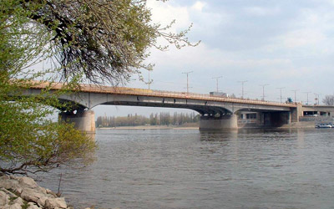
Margaret Bridge (1872, but it was renovated in 2008)
length: 637,5 m
width: 25 m
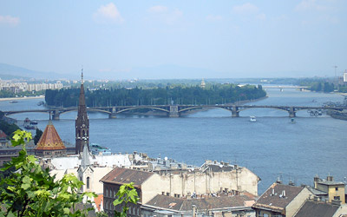
Chain Bridge (1839)
length: 375 m
width: 14,8 m
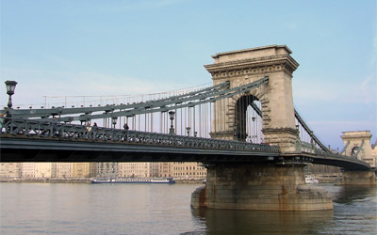
Elizabeth Bridge (1961)
length: 378,6 m
width: 27 m
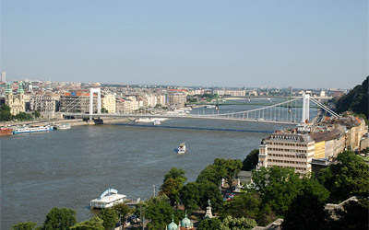
Freedom Bridge (also often called as Liberty Bridge) (1894)
length: 333,6 m
width: 20,1 m
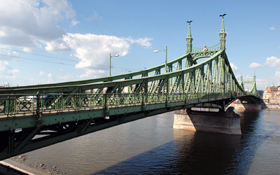
Petőfi Bridge (1933)
length: 514 m
width: 25,6 m
