ERASMUS EXCHANGE PROGRAMME TO SCOTLAND
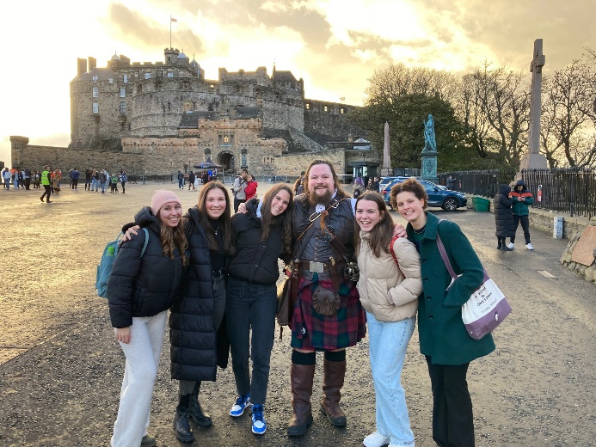
11.06-11.11.
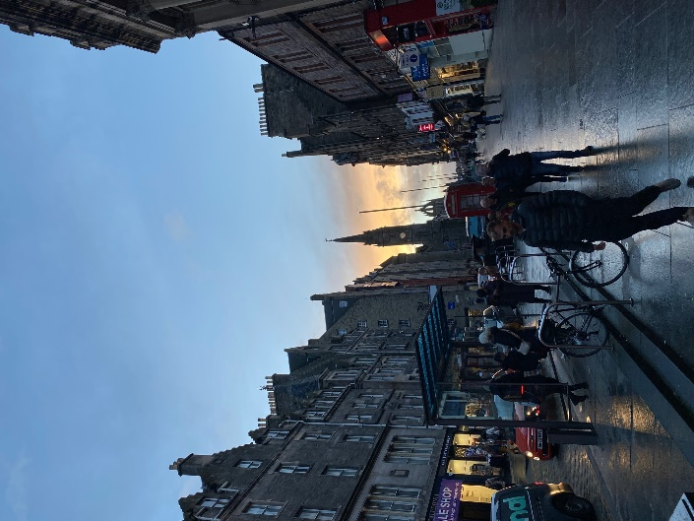
On our first day (11.06.) we met up at the airport at 8 am, then our plane took off at 10:30. Until then, we had the opportunity to kill time in the duty-free shop. The plane ride was great, everything went well, we also got our luggages, then used the Edinburgh tram to get to our hotel. It’s located in a beautiful place full of nature and greens. It’s also a very modern building, we’re really pleased. Once we got settled in, we got back on the tram, travelled 20 minutes to explore Edinburgh. The city was beautiful, full of history and lots of beautiful stores. We visited the castle, the St. Giles Cathedral as well as many other places. We also got to take lots of beautiful pictures. We heard bagpipe music on the streets, and we also got to take a picture with a traditional Scottish man wearing a kilt. We finished the day by having dinner at McDonalds. Overall, this day was perfect for us to really get to know each other, we had some great laughs, and we were also able to get used to Scottish weather. We were all looking forward to meeting our hosts the next day.
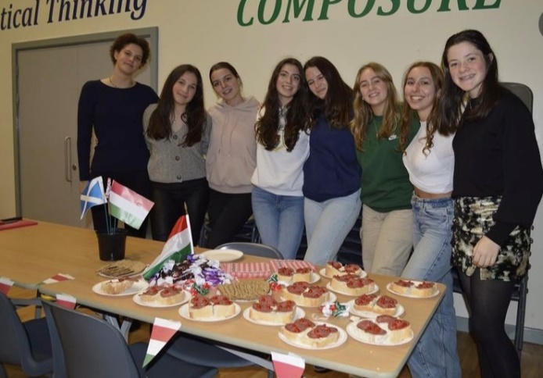
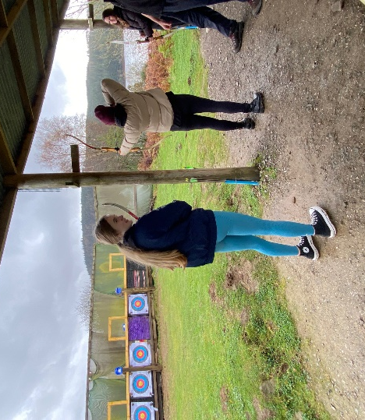
On Monday morning (11.07.) we all woke up at around 6:30 and had breakfast at our hotel. There were lots of options to choose from, toast, pastries, ham, and cheese, as well as coffee and tea. From our hotel we went to Thornhill by bus. We went with the rest of the exchange students, so the Germans, Belgians, and Estonians were all in the bus with us by now. Once we got to Wallace Hall, we all met out hosts and sat down to get to know each other. After that, every country made a presentation about their school and country. Once we were all done with our presentations, we had a food court. Every county brought some of their traditional foods for all of us to try. We also got a tour of the whole school, which was interesting considering it’s a lot different compared to our high school back in Budapest. The final activity of the day was dancing. First, we did Scottish dances, then we all learnt the Belgian and Estonian traditional dances as well. Once the day was over, everyone went home with their hosts. We all had dinner together, got tours of their houses, and got to know everyone by doing fun little activities, like walking around town or playing board games.
On Tuesday morning (11.08.) we all went to school with ours hosts, the way they usually would, which is mostly by bus. Once everyone arrived at the school, we all got on a bus and headed to Galloway Activity Centre. We took part in three activities here, which were laser tag, rock climbing and archery. For these team building activities, we were divided into three groups, according to our countries. Our group started off with laser quest, which consisted of two teams, red and blue, and took place in a forest, near Loch Ken. Next, we participated in rock climbing, where we had a warmup, and then had the opportunity to race each other. After that, we had lunch, where you could choose from various kinds of sandwiches, crisps, drinks, and cookies. Our final activity of the day was archery, where we learnt how to use a bow and arrow. At the end we raced to see who could get the most points. At the end of the day, we had a long bus ride home, then once we got to Thornhill, everyone spent the evening with their host families.
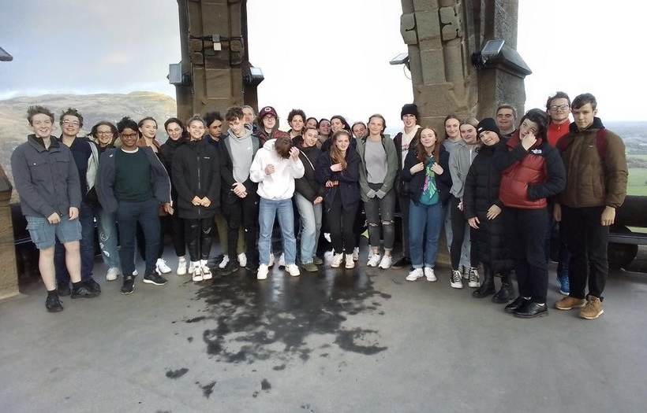
On Wednesday (11.09.) the group took the journey to the historical city of Stirling. We had a long journey on the bus, but we killed the time by singing and listening to music together. Once we arrived, we all explored the beautiful Stirling castle, including walking around the vaults which provided an insight into both the activities and fashion of the time. Everyone's favourite exhibition was the amazing banquet hall showing off the grand way of dining and the 'interesting' food choices. After that, everyone had the opportunity to have lunch in the city. Following that we took a visit to the Wallace monument which included all 246 steps to reach the amazing view of Stirling, within the monument there were three levels full of interesting displays of Scottish history. To conclude our eventful day, we made the trip to The Kelpies, the impressive sculptors provided many great photo opportunities and a lesson on Scottish folklore. At the end of our tiring day each student had a peaceful dinner with their host families to prepare themselves for the next day.
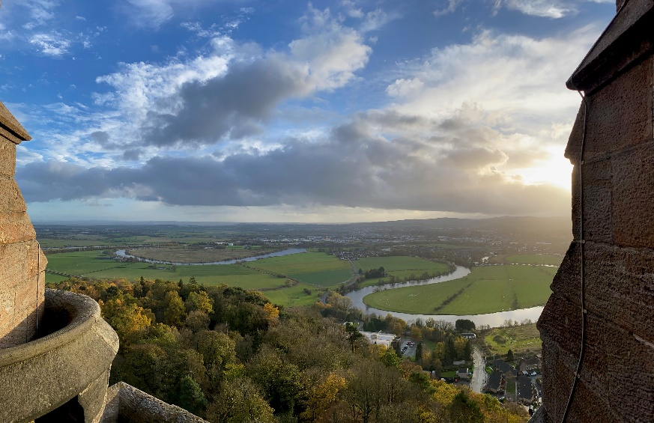
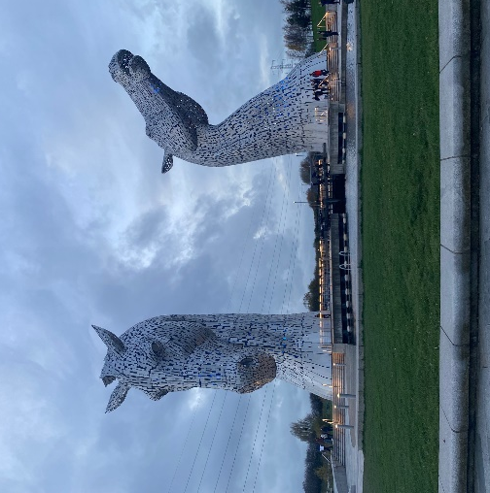
On Thursday (11.10.) we had the opportunity to work on the project by collecting all countries opinions on how they have experienced and how their government attempts to resolve 21st century challenges, including inclusion, acceptance, and economic crises. There were all sorts of tasks, including creating PowerPoint presentations, making surveys, and writing reports. Once we were done with our project work, we could explore the school and the town a bit more, because we had a lot of free time. We could do things like, joining a PE lesson, where we played volleyball, some people visited a nearby castle located in Thornhill, while others took the train to Glasgow to experience Scottish city life. Most people had lunch at a place called Thomas Tosh, which was a very aesthetic little restaurant close to Wallace Hall. Having a more relaxed and peaceful day, we all chose to stay at our hosts’ houses to have a movie night. Finally, considering that we were going to be leaving the next day, we all packed our suitcases before going to bed.
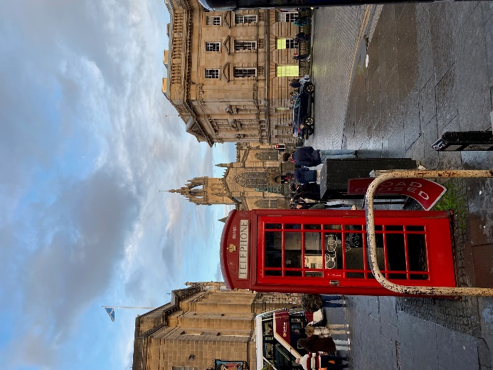
On Friday morning (11.11) we woke up earlier than usual, because our bus was leaving from the school at 8:15. After saying our emotional goodbyes to our host families, we left to Edinburgh. Since we had to drop off the Germans, Belgians, and Estonians at the airport, only the Scottish students hosting the Hungarians joined us on the trip to explore the beautiful city of Edinburgh. Our first destination was the National Museum of Scotland, where we learned about Scottish history through interactive activities and exhibitions. Before our next adventure, we all had lunch together in the city. The group’s final program was the famous ghost tour of Edinburgh, where we explored the underground vaults. Our lovely guide Scott told us all about the mysterious history, secrets, and paranormal activities of the city. At the end of the day, we went to the airport, where we all said goodbyes to each other with our hosts. Fortunately, our flight wasn’t delayed, everything went well, and we arrived to Budapest at 23:25. Overall, everyone had an amazing time this week, and we can’t wait to host our Scottish friends in February.

