Exchange with Belgium and Germany in Budapest
10-14 October 2019
by Júlia Sallai, Daniella Ditta Kiss, Levente Szűcs and Luca Debreczeny
The Belgian and the German students arrived on Sunday and everybody spent the rest of the day with their host families. On Monday we had to wake up early, but still later than usual, which gave us more time to sleep and to be in a better mood for the week. The first thing that we had to attend on, was an informational „lesson”, where our teacher Mr. László Békési told us every important detail about the week and what will we need to do. We got some papers, where the programmes were written down. Afterwards we made a huge facebook group, with all of the students and teachers , in order to post videos, pictures and later the presentations there. The last thing we did during this lesson, was picking cards blindly, to form in random teams of 5 or 6. Our task with our team members will be to make presentations about topics connected with water, and we will have to present it on Friday.
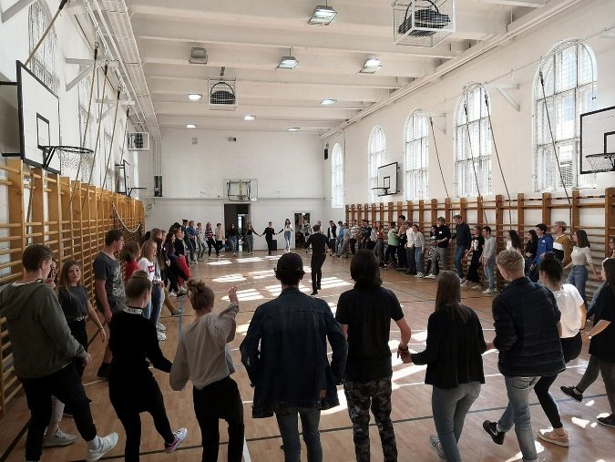
Later on some of my classmates showed the foreign students around the school. We visited the most interesting areas, like the gym, the conference room, the theatre room, some of the classrooms, and the outside sports centre. After that, we could join some language classes and talk with students about our experiences with the exchange programme or just listen to their lessons.
Our next programme was traditional Hungarian folk dancing. We stood in a big circle and learnt some easy and fun moves that everyone really enjoyed.
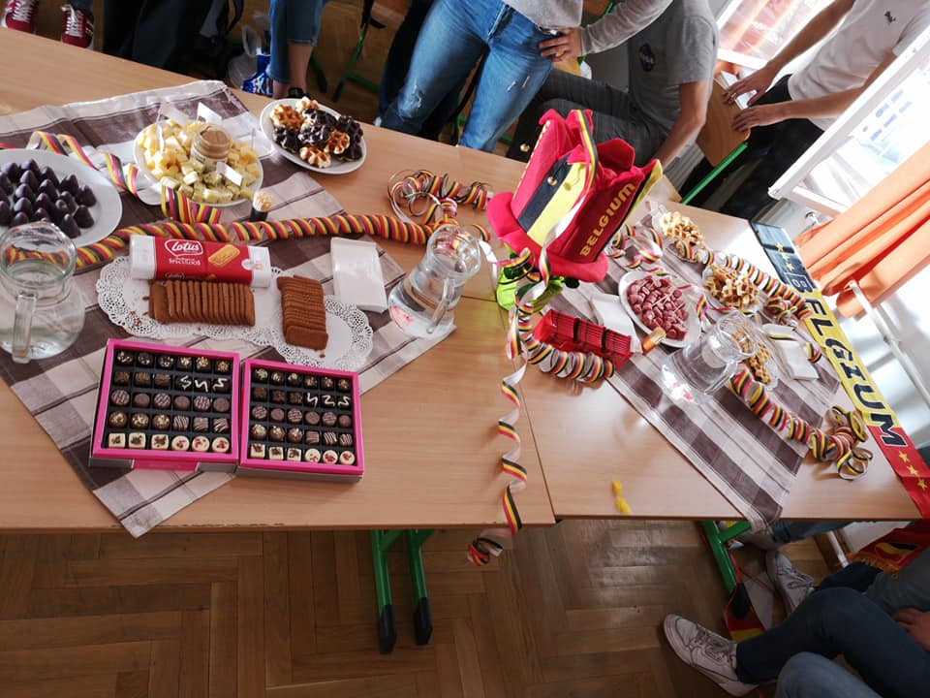
After the exhausting dance lesson, we had lunch at the school canteen. We had a little free time during lunch break, so some of us went to watch the football match, that the school organised for the boy students.
Before our last task, we had a food court, where each country presented some of their traditional dishes. The Belgians brought some delicious waffles, the German students had similar desserts to Hungarian ones, but they were tasty as well, and we made them some sandwiches and showed them what „túró rudi” is.
Finally, all the three countries presented a powerpoint presentation about their own school and country.
On the second day, Tuesday, the Germans,Belgians and the Hungarians gathered together in the school library, which became the usual project and meeting spot since there were enough room for everyone and the library is equipped with laptops and projectors. The day started with a lesson held by our beloved geography teacher András Pethő who talked about the World Oceans and Seas and how water can affect our world and how important it is. After the lecture, the students countinued to work on their presentations based on the information that the teacher gave us in his speech and in his handout papers. After the usual project teamwork everyone headed to eat luch in the school dining room. After the lunch we headed back to the library to pack our stuff because we had a Budapest sightseeing tour with our (also beloved) history teacher, Gábor Harmath. He shoved us the famous tourist attractions such as the Buda Castle and many other things which the Germans and Belgians had found really fascinating. After the long tour there were also a quiz which was about the things that the teacher said about our beautiful city. At the end of the day a lot of us went to a café to talk about the day and rest a little bit. Then everyone went home to have some sleep.
We arrived at half-past eight in the mornings during that week. After we greeted each other we continuted to do our projects from the topic we have got on the first day. Every group had to have a German, Hungarian and Belgian student. We spoke English during the team-work. In the beginning, we didn’t know how to start it but after a while, we got an idea and we have begun to collect expressions and pictures. At the end of this exercise we learned a lot of skills for example: how to cooperate with the others, how to use English in projects, how to share tasks, how to share our opinion, open up our mind for new methods.
At 1 o’clock we ate our lunch in the canteen of our school, the Belgian exchange students liked Hungarian dishes because they don’t really have special ones there. After lunch, we had free-time. At that time people could choose between relaxing in the library or going out to the playground of the school and play football, basketball or just work-out. When foreign kids joined the football, half of the school was cheering next to the pitch.
Later we went to the museum together. In the afternoon we visited the Hungarian Natural History Museum. We spent there a few hours but for a lot of people from us, that time was too short, because that institute was way more interesting than we imagined it. We could see life from the age of the Archaean, for example how people hunted, how they looked like and what kind of animals lived here. There were also a puzzle game we could play.
After all the activities, the exchange students and their hosts could go home to their families. Instead of going home, most of them chose to stay together and travel by boat in the Danube, visit Liberty bridge and eat chimney cake together. At the end of the day we were exhausted because of that many programs we had that day.
Friday was our last whole day together with the Belgian students, which was a very bittersweet feeling. We didn’t want this exchange program to end, but we still had some pretty interesting activities to do.
We went to school in the morning as usual, and we had enough time to finalise and practise our presentations. We had fun during the week as we were working on our project but we also tried to do our best. After we finished our work, we had some free time, which we spent on the schoolyard together. Some people played soccer, some people were just sitting or watching others, I played volleyball with about 5 other girls.
After lunch, we went to the school’s theatre room where we presented our projects to everyone from the exchange program and also to Hungarian students from our school. We were a little nervous I think, but all of our speeches went well, I personally learned a lot from the others. Then we ate cake and got some papers, and a photo of us together which was taken on Wednesday.
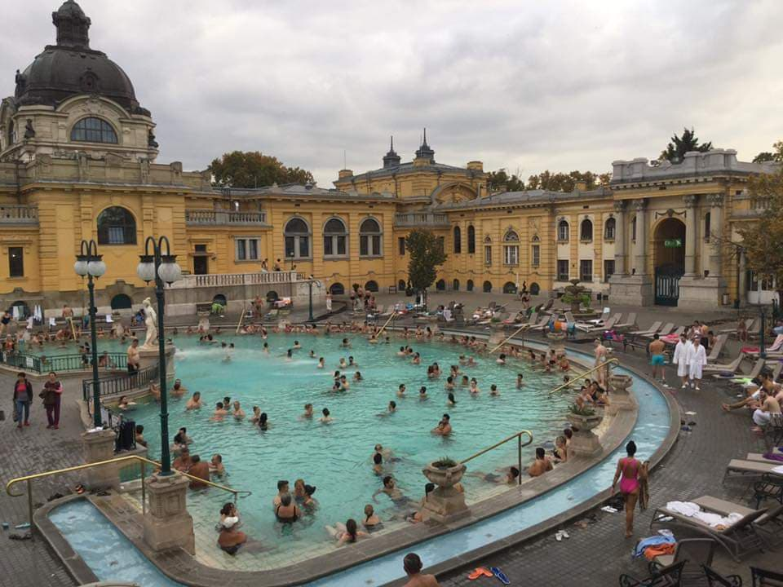
Next, we visited the Széchenyi spa, which is one of Hungary’s most famous thermal baths. Personally, that was my favourite program, we laughed a lot and had a truly amazing time.
Our last program together was not connected to the school, we decided just to sit at Margaret island and talk without any responsibilities or any given topic, we were there until around 11pm.
When we got home we were extremely tired so we went to bed right away. I would recommend anyone who is thinking about applying to an exchange program to stop hesitating, because it was one of my best weeks in my life.

