Hungarian-Scottish Erasmus+ exchange
by Regina Farkas
18-22 November 2019
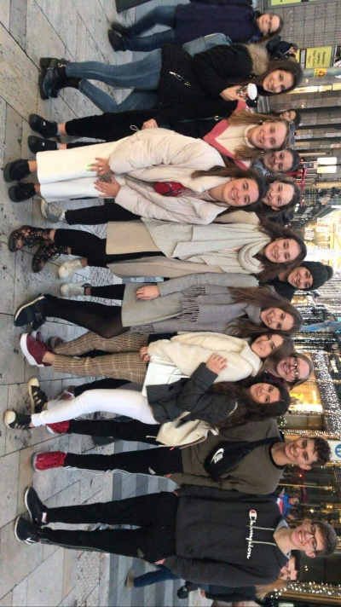
On the first they of the exchange programme, we went to Liszt Ferenc Airport to greet our guests. When they finally arrived, we waited a bit to get their luggage and then we went back to the school. By the time we were ready to leave, it was almost lunchtime so we rushed back to our school where we had a nice meal and a great conversation. The next activity we had was sightseeing. We went to a boat trip and then used different means of public transport (because this was the topic: public transport).We ended up at a Christmas fair at Vörösmarty Square which everyone really enjoyed, so we went back there again on the following days. Everyone was really tired so the students went home to meet with their host families.
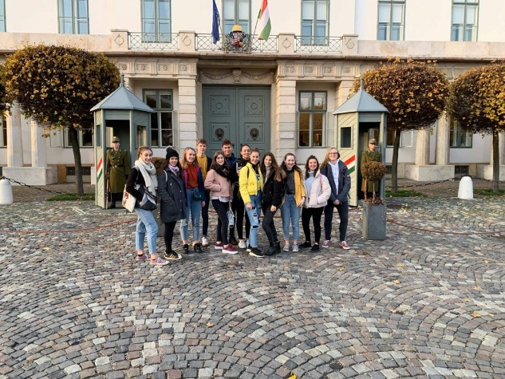
On the following day we showed those parts of our school’s building that the guests didn’t have a chance to see. Later, we visited a few classes to see the differences between education in Scotland and Hungary. Later on, we worked on our projects, got divided into different groups. Then we head a trip in the city, including Buda Castle and the Underground Museum and then we went to a café and had dinner. We think that this was the best day of the whole week because we got to know each other a little bit more.
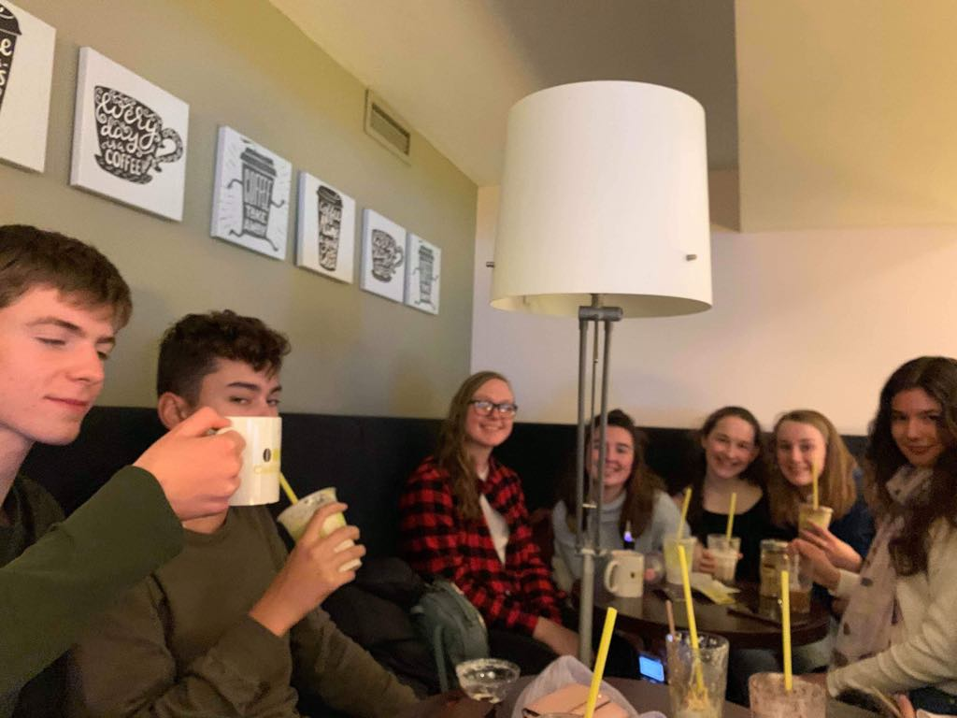
On the third day we met at Széll Kálmán Square in the morning. It was quite early but we had a long day instead of us. First, we went to Zugliget by tram and then we got on to children’s railway which was really interesting because it is quite unique in the world. It took us to Buda Hills and then we walked to Normafa where we had some Hungarian sweets. Our groups came down from the hills by chairlift which was stupefyingly great although it was raining but it made the ’travel’ funnier. We went back to the school, had lunch and went to the centre of BKK where we had a chance to see how the different means of public transport are managed. When it was over, we went to the downtown to see more parts of Budapest in the company of coffee.
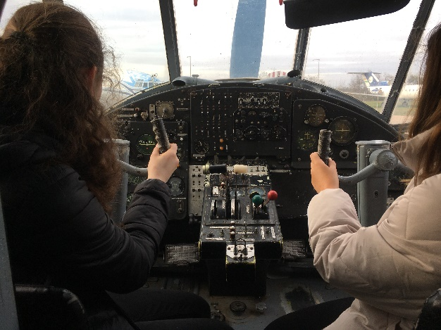
The next day, we had an unusual programme: we went to the airport but not to say goodbye but to see the inner parts of it. First, we went to Aeropark where we could have a look at those planes that by now are out of order, and it was really interesting. Then we had a tour around the airport, where a nice worker told us about the everyday work they have here. We also saw a fire station which also belonged here. It was a really long programme so it lasted basically all day. We went back to the city centre and grabbed dinner together.
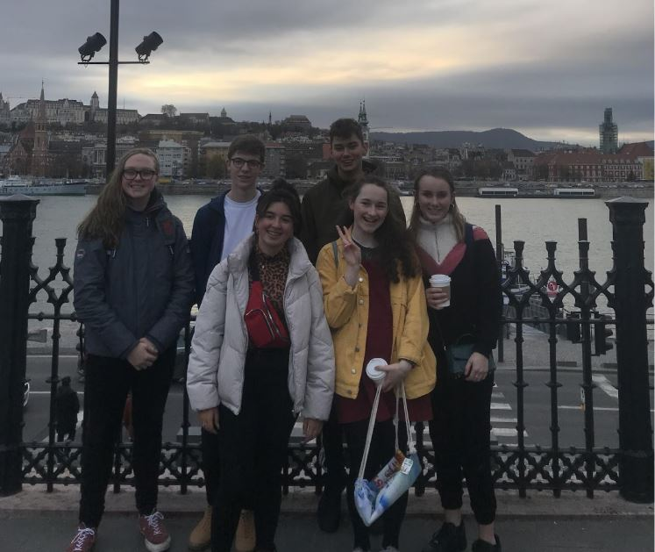
Sadly,our last day came. We finished our projects and then we presented it to many of the students in our school. We talked after it, got some feedbacks on the presentations and then went home because we needed to get ready to leave. A few hours later we met at the airport to say goodbye. We hugged each other and promised to keep in touch. We waited until they left and then went home.
All in all, it was an amazing week, made the greatest memories and made new, lifelong friendships. We learned about the cultural differences, taught each other many new things, talked about serious problems within the topic ’there’s no planet B’ but first of all: we had fun.

