Comenius exchange in Poland, Tychy
23rd February – 2nd March 2013.

We have been waiting for the moment when our Varsovia EC train leaves Budapest since our Polish friends left us after their visit in October.
We were looking forward to meeting again after 4 and half months! During our short – only seven hours - train ride we had time to get prepared for our presentations on Monday and even to rest a bit. We all felt that going to Poland was an great idea, not simply because of skipping school, but also because of the opportunity to meet old friends and new people and places.
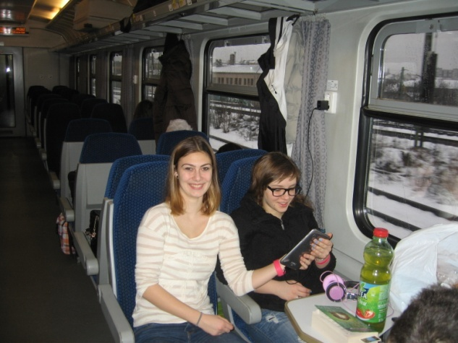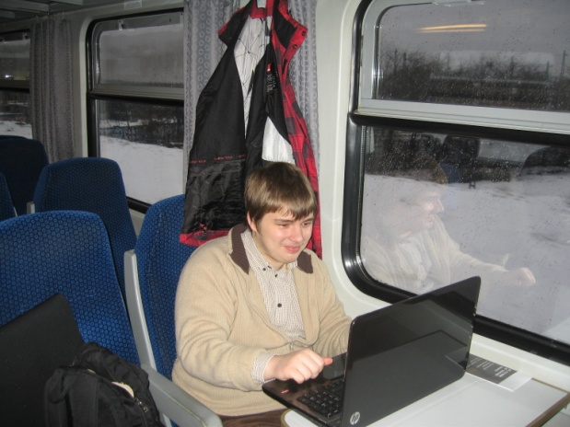
As we arrived on Saturday, Sunday was our family day. Our hosts took us to visit Cracow, the former royal city of Poland where we saw the royal palace, Wawel and the old Jewish quarter, called Kazimierz where the film Schindler’s List was shot.
Project work started on Monday as we formed our mixed international project groups – there were Hungarian, Polish and Belgian students present - and after some team-building games we set down to work.
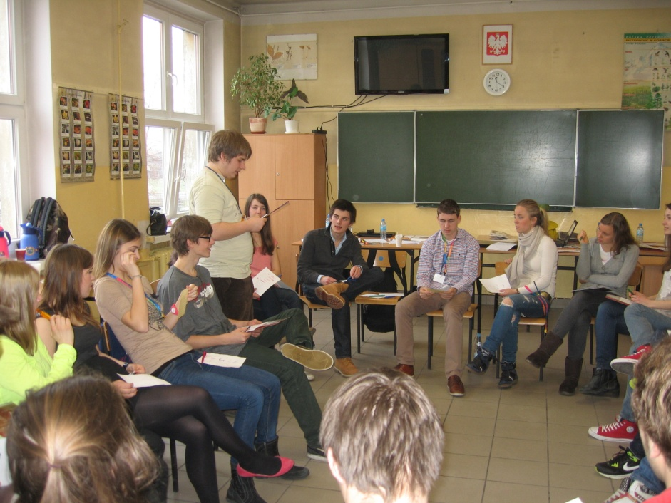

We had to prepare presentations on different topics. The main theme was food; we had to think about new food sources, sustainable production and consumption, how to feed the poor and the requirements of the ever growing population.
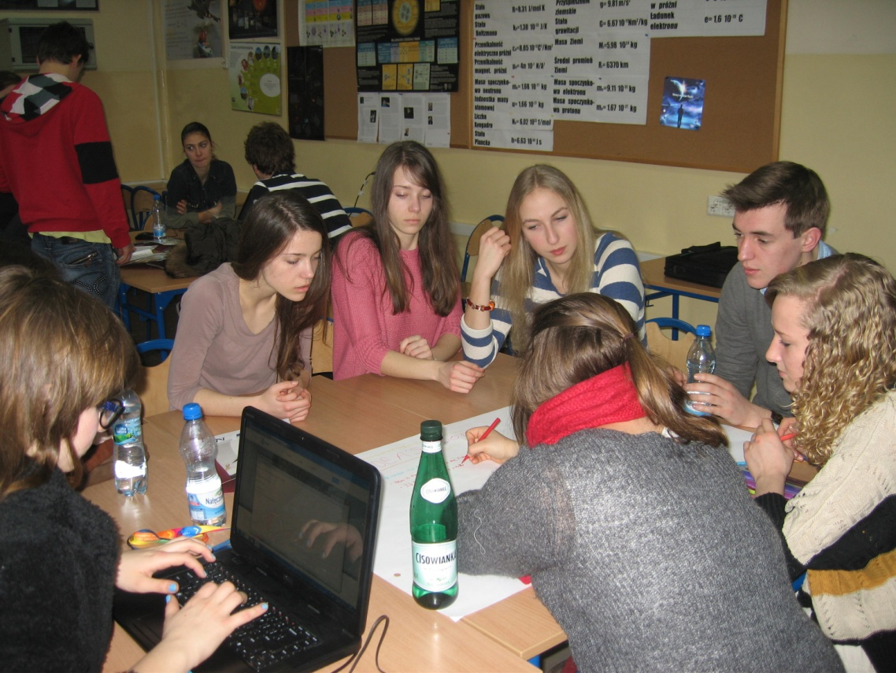

The next day we visited Krakow where we saw the archaeological museum and listened to a lecture about GMOs (this topic was related to our projects) at the university.
On Wednesday we were working on our projects. The only problem was the school’s wifi system, which did not work very well.

On Thursday we went to Auschwitz to visit the concentration camps. This experience was shocking and horrific. People really have to see with their own eyes where it all happened, because no history book can describe the horror of killing millions.
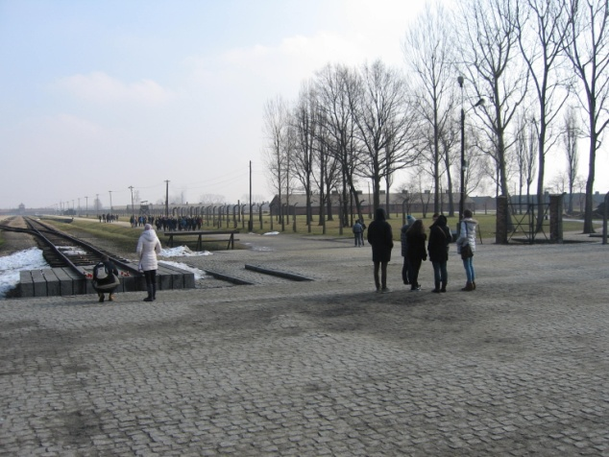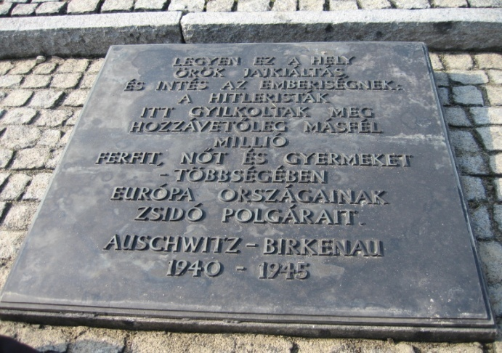

On Friday morning we finalized our work and then we had our presentations. We finished our program together with a funny party organised by the host school.
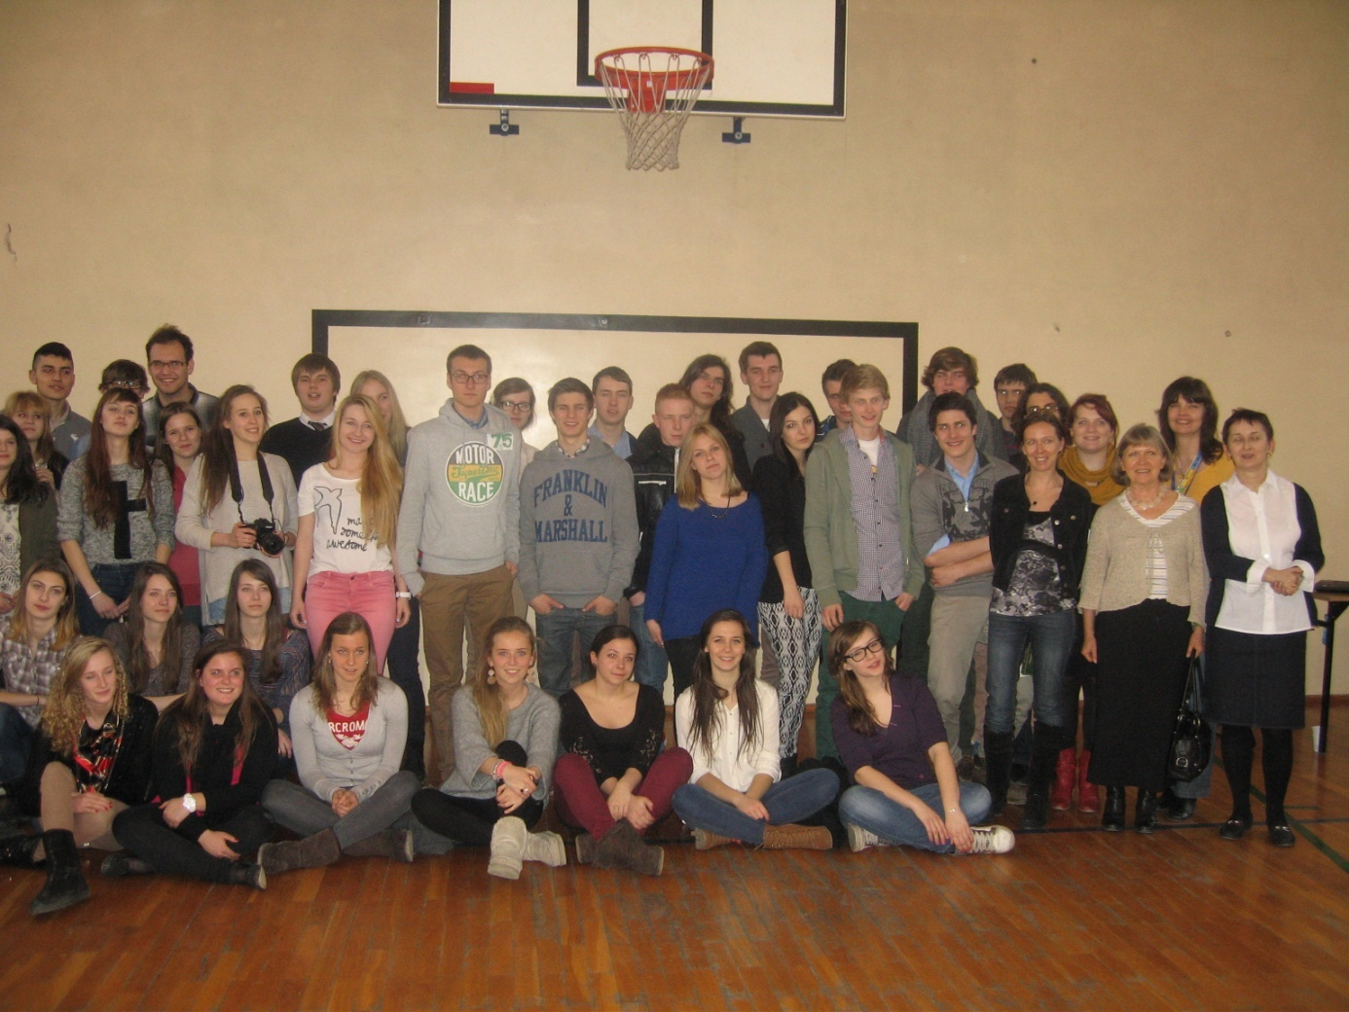
Every day after the daily programs we went to cafes, pubs or parties organized by our Polish hosts, where we got to know each other a little bit more. Our host families were simply amazing, and we hope to see our exchange partners sometime in the future.
We left Tychy on Saturday by train – another short 7-hour-train ride! This program created long-lasting friendships and international connections!
Mehdi Ben Ali and Benjamin Sóti Hungary

