A week in Waregem

Our school organizes student exchange programs with Comenius, and I happened to take part in the trip to Belgium, Waregem. As it’s an exchange program, first we hosted Belgian students in Hungary, last year in October. We had a great time then so we were all looking forward to our visit to Belgium.
We had to wait four months to travel and we didn’t have a lot of contact with the Belgians during that time but in March we became really excited and remembered how much we were looking forward to this trip. One of the Hungarians moved to Bulgaria so we got a new member in our group.
While I was packing my bag the evening before the journey, I was thinking about what it was going to be like there, what might be different and I wondered if I could express myself in every situation. I was quite nervous.
The journey was fine, we arrived at noon and our hosts were waiting for us at the airport. It took two hours to get to Waregem from Charleroi Airport. My host family was really nice; I could get on well with everyone from the very first night. We ate dinner and went to a pub called Bar Choque where some Belgian students spend most of their free time. We met some of the Polish and Spanish people there. It was really nice.
Next day we went to school by bike (we used the bike quite a lot as we lived the closest, I think), which was a pretty bad idea because of the weather. I don’t know why, I’m not the person who often gets colds but I definitely became ill that day, and I remained ill with a bad cold all week. Anyway, we met a bunch of new people that day, there were Norwegian, Polish, German and the host Belgian students and their teachers as well. It was very exciting and everybody was really open-minded and kind. They showed us around in the school, which I found awesome.
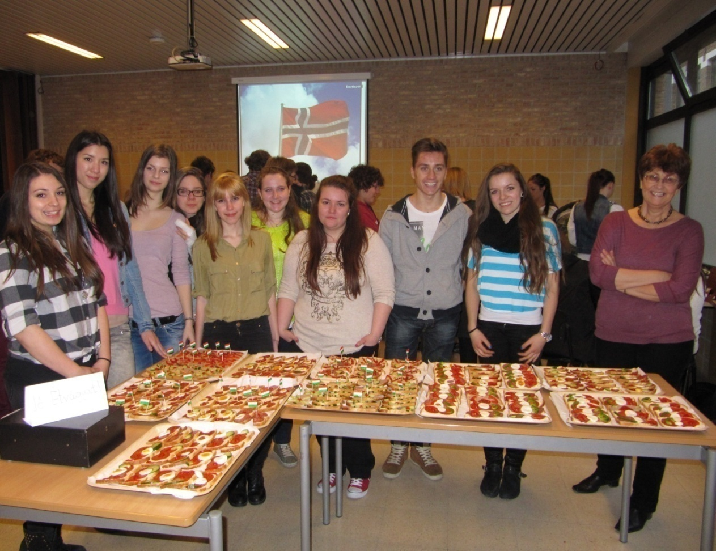
In the afternoon we set up the food stalls and ate a lot of different types of food. The parents and the teachers also came and admired our “food exhibition”. We didn’t go home after school; we went straight to a karaoke bar. This night was one of my favorites.

On Tuesday we left for Bruges in the morning. We went for a boat trip there. It was beautiful, but cold. I took a lot of pictures; we also saw a dog hanging out of the window. We bought some chocolates and food here and discovered the city.
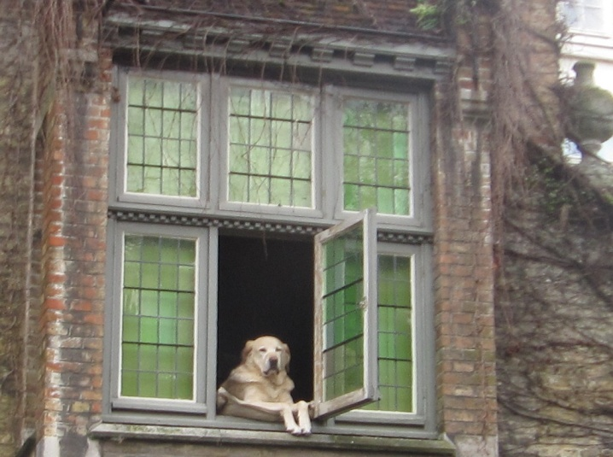
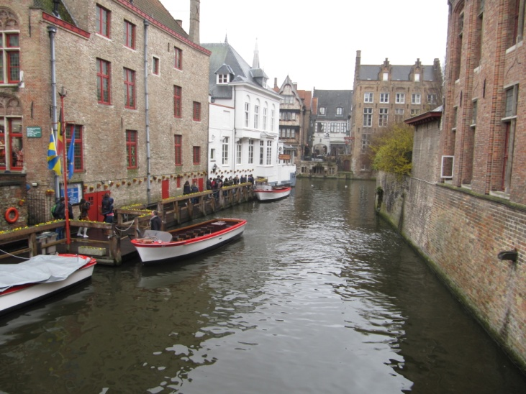

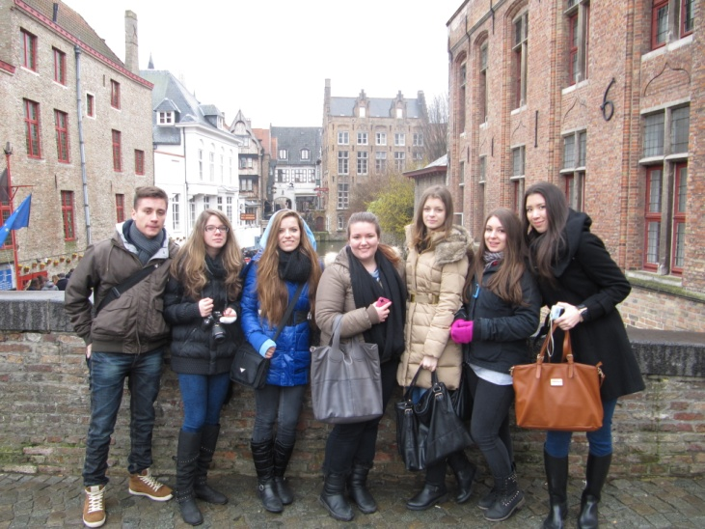

On Wednesday we had to choose a project task and we ended up doing a photo montage of bridges from every country. This was a good choice, we enjoyed doing it and in the end we were satisfied with what we had done. We worked hard all day and in the evening we went to the Bar Choque.

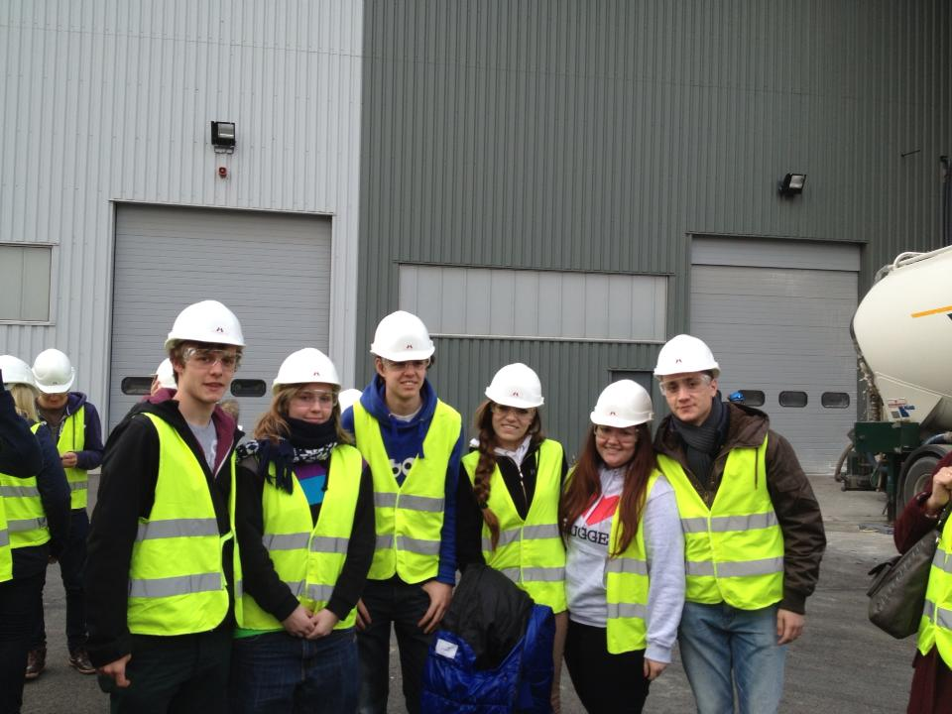
Thursday was our busiest day. In the morning we went to Antwerp (without our exchange students!) by bus and we visited Antwerp Harbour with the help of a guide. It was really interesting for someone – like me – who comes from a landlocked country!

In the evening we went to a big barbecue party organized by the school, where we learnt some national dances and had a lot of fun, but also had to say goodbye to the German students.
First thing on Friday we went to school and finished our project tasks. The Norwegians had to leave in the morning. When we were ready, we set up our exhibition, and the presentations started. In my opinion everybody worked hard and the results were great. The teachers were pleased, and the students took the credits.
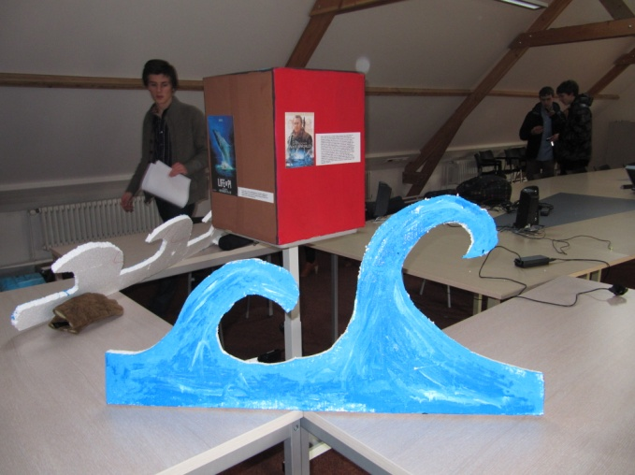
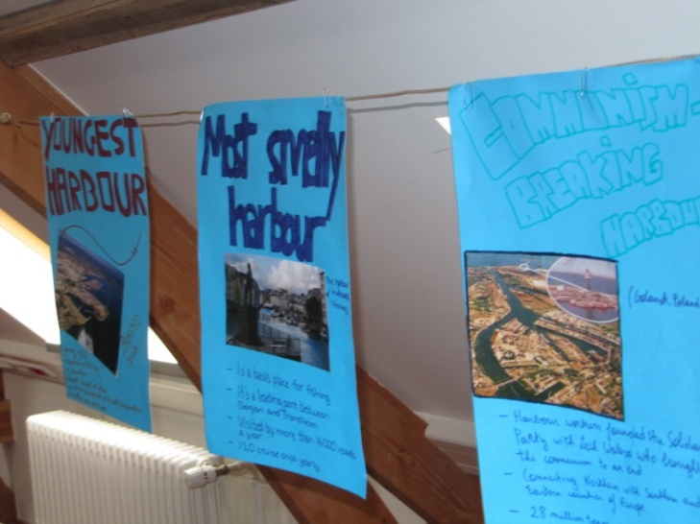

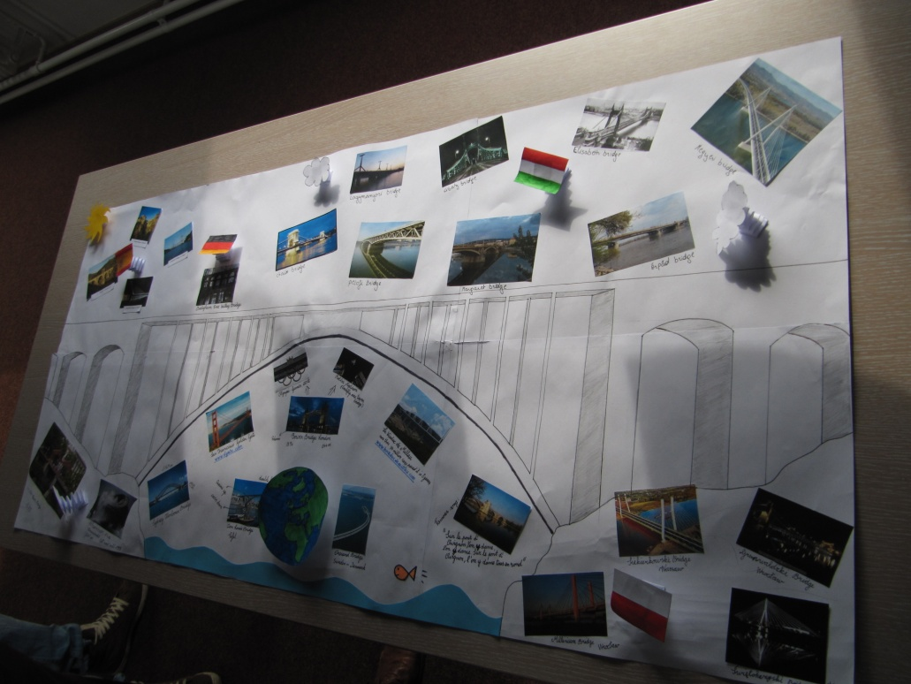

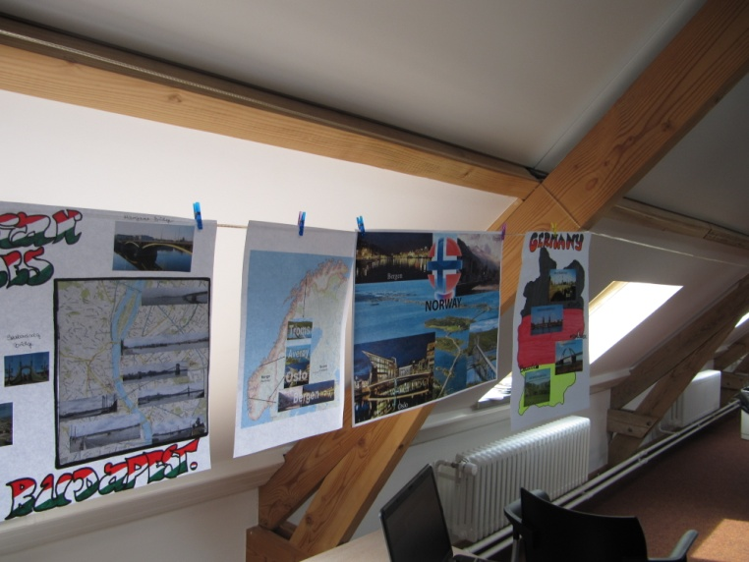
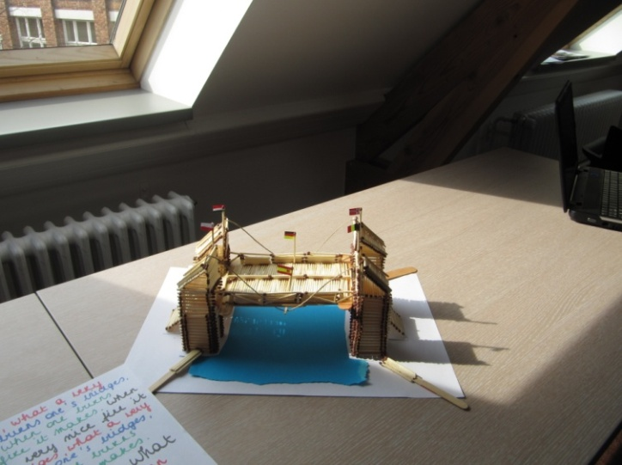

That was the last day we saw some of the foreign students so the end was sad, but in the evening we went to the Bar Chaque and had a great time, though we were tired.
The next day we could sleep a little longer, and woke up more relaxed. We went to see Brussels this day, so my exchange student’s mom took us to the railway station and we met the others. Brussels was beautiful, but the weather was awful again, it started snowing so we couldn’t walk around the city. We bought some chocolate and beer for our family and went to a pub called Delirium Café.

In the evening the others went to a party but we stayed at home and celebrated Giebe’s (my exchange) birthday. One of his best friends and his family came over and we played a lot and had a great time.
The last day was really sad. I got up early because Giebe had an important game that he couldn’t miss. We said goodbye and I went back to sleep. Later his father took me to the car park and another host family gave me a lift to the airport. I was so tired that I couldn’t even think, so I didn’t cry or anything. I was looking forward to getting home, but still it was a great time and an unforgettable experience.
Petra Kőszegi, Hungary

