Visit to the organic farm
On the 16th of October the entire group visited an organic farm in Zsámbok, which is approximately 50 kilometres away from Budapest. The weather was not so good. It was already raining when we got there. That’s why our trip was cut short.
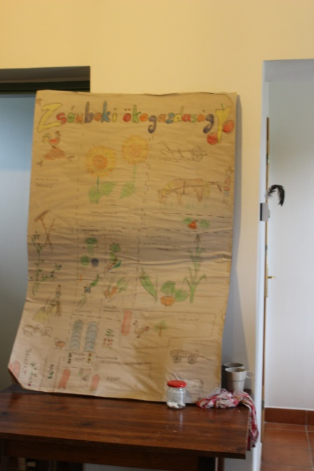
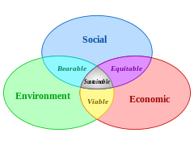
At first when we arrived we got cookies and tea (which were made by the farmer). We had to go inside of his house and he started to explain what organic farming means. One of the main idea is to ’feed the ground and the ground feed the plant’. The soil and the water are the most important elements of organic farming. Sustainability is a stable system. It’s the meeting point of the aspect of environment, economy and society. It’s important because they’re planning for 50 generations, not for 5. This farm can be divided into 11 parts. These are the followings:
- vegetable garden
- hay stacks
- alfalfa field
- green house
- horses
- chickens
- vegetable fields
- pumpkins / corn/fruit trees
- chicken/fruit trees
- field with rye
- compost / manure

He took us around his farm and we had a stop at every section where he gave us more information about them. It was very hard to listen because of the rain and we had to watch out to not to slip in the mud. The size of his farm isn’t very big but it’s very productive. After 15 minutes we went back inside where we ate some sandwiches and some tea. Everything was produced at the farm and had a special taste. Especially the apple pie was very tasty.
It was a really good experience to understand the difference between the industrial and the natural system. In the industrial system there are less and less resources because there’s a lot of waste, which we can’t recycle. In the natural system nothing goes to waste and everything is re-used, that’s why it’s a semi-closed natural process. There’s no big difference between the organic and industrial fruits but organic fruits are healthier, and better for our environment.
Michael Hayes spoke about himself. He is from England but he has been living in Hungary for over 15 years. He started to study about organic farming 30 years ago. He moved to Zsámbok 2 years ago. We made a short report with him.

