Where Our Water Comes From and Where It Ends

Visits to the Central Sewage Treatment Plant and Water Reservoir of Budapest

In our Comenius project “Dwindling Resources Growing Challenges” it is essential to draw people’s attention to the importance of saving water and energy and the rational use of our natural resources.

On the third day of the exchange programme (on the 15th of October, 2013) half of the group went to the Budapest Central Sewage Treatment Plant

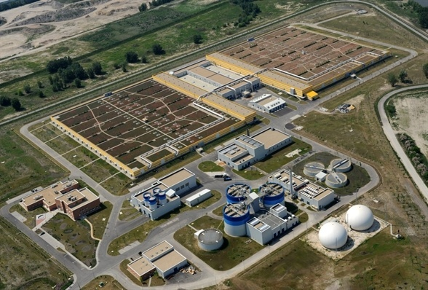

and the other half went to the József Gruber Water Reservoir of Budapest.

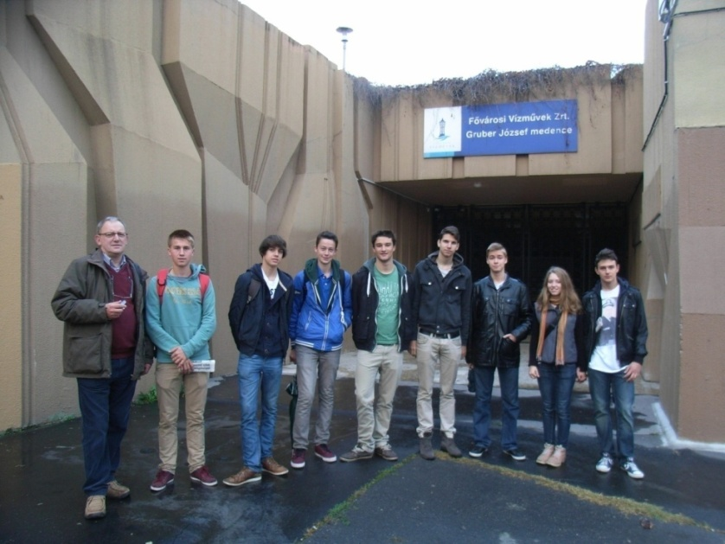

Both of them are essential for the water management of Budapest. Our group is writing a report about these.

Let’s begin with a short overview of The Water Works of Budapest, which is 145 years old. It provides 1.8 million citizens with healthy drinking water every day. Drinking water is vital, its existence is a basic requirement for our lives, yet it is a natural resource which our planet has always been in lack of.

Visit to the Water Treatment Plant

The Budapest Central Wastewater Treatment Plant, which is one of the most modern, state-of the- art plants in Europe, is located on Csepel Island of the Danube. They treat the wastewater produced in Buda and the Central districts of Budapest. Since it was opened and in full working order in August 2010, 95% of Budapest sewage water is treated, before its opening, this rate was only 50%.

Let’s see what happens to sewage water that enters the plant. There are two pumping stations, one in southern Buda and one in southern Pest. They move sewage water to the plant. The plant produces biogas from all of the sludge, so 60% of their energy need is provided by biogas that the plant actually produces for itself. They only have to buy 40% of their needs.

The main steps of treatments are the following. First the water has to be cleaned. About 10,500 m³ water is cleaned every hour. At first fine screens are used to remove the biggest particles from the water.

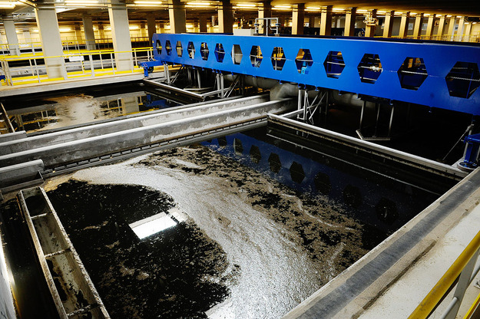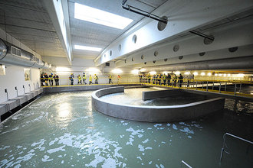

Then grease, sludge and grit are removed from it.

Then, the water is disinfected and the separated sludge is thickened with the help of gravity. The sludge is heated for 30 minutes at 70°C to kill bacteria. This pasteurised sludge is left for 12 days at 55-56°C to digest. This sludge could be used as fertilizer. At the end of this process the cleaned water is finally let into the River Danube.

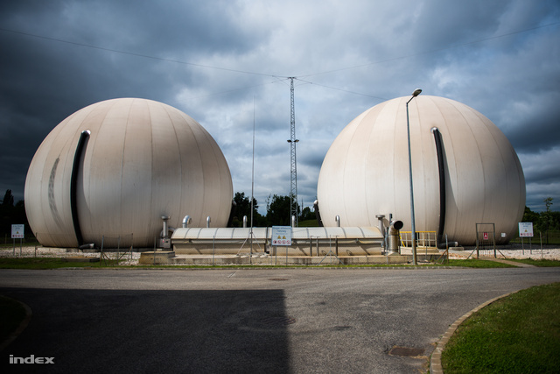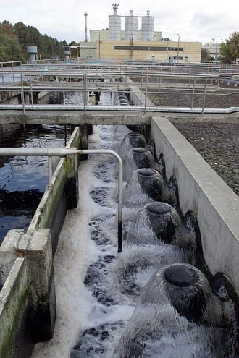

Visit to the József Gruber Water Reservoir

The water reservoir is a place where water is stored before it gets to the water pipes of Budapest. The water reservoir is located in and under Gellért Hill.

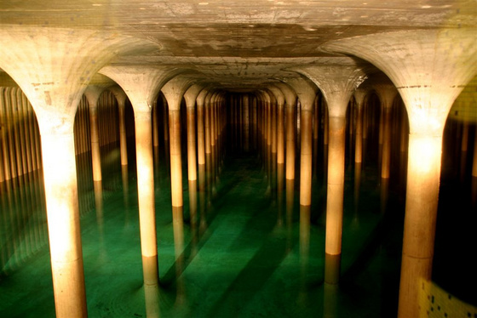

It was built between 1972 and 1980. The capacity of the two reservoirs is 2x 40.000 m³ but the residents of Budapest use 400.000 m³ of water per day. This construction is earthquake-proof with 35 cm thick walls.

It has two symmetrical basins. Both of them are ten metres high and there are 106 columns in each.

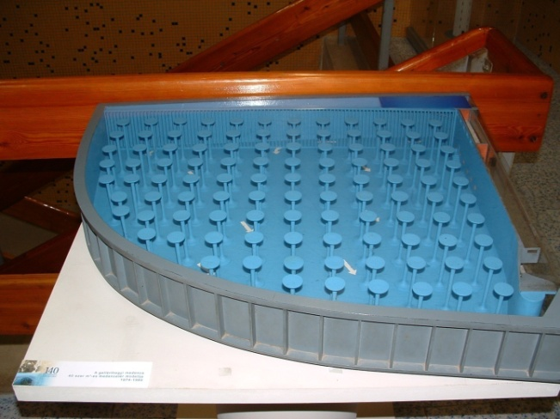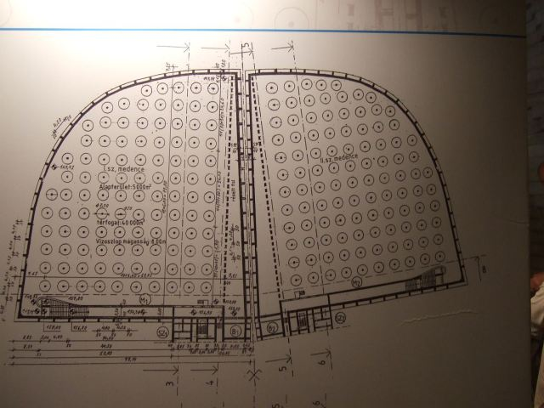

The ceiling is special, because water vapour can’t stick on it, so biological life can’t exist there. Once a year it is drained and checked by workers and the water is changed daily.

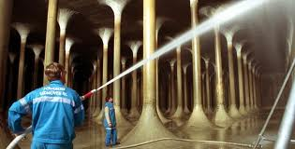

The quality of the water is also checked regularly and it is maintained. Its quality is ensured by two main steps: water is constantly circulated in the reservoir (clear water comes in to the basins in one side and flows out on the other side); and air over the water is also circulated. (image10)
The wells from which all the water for Budapest comes are along the bank of the river Danube.

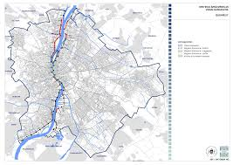

70% of the drinking water of the city comes from Szentendre Island, 30% from the Csepel Island and a few per cents come from Margaret Island. The wells are located on the riverbank because the pebbles there function as natural sieves and remove quite a lot of dirt. Water is pumped to the hill in small steps. Another function of the water reservoir is to make sure that water pressure is stable, so if you open your taps in your home, water comes out evenly. This system is very important because without this, people in Budapest wouldn’t have clear tap water.

Our personal impressions of these visits are great; we think they were very instructive and interesting. We got to know a lot of new things and astounding facts about Budapest and about the waterworks of the city. We also got to know the process how clean drinking water gets into our taps at home. You can visit these places on International Water Day on the 22nd of March.

Written by Izabella Péntek, Liesbeth Vanden Berghe, Flóra Péter and Arne Christiaens based on their personal visits and the official website of the Budapest Waterworks Company www.vizmuvek.hu

Sources:

Image 1: https://www.google.hu/search?q=budapesti+v%C3%ADzt%C3%A1roz%C3%B3&source=lnms&tbm=isch&sa=X&ei=HX1eUpumB-Gm0QXC6IHYBw&ved=0CAcQ_AUoAQ&biw=1280&bih=709#q=budapesti+szennyv%C3%ADztiszt%C3%ADt%C3%B3&tbm=isch&facrc=_&imgdii=BBa-zNVr0dq_aM%3A%3BCkiKbHEGhDh0GM%3BBBa-zNVr0dq_aM%3A&imgrc=BBa-zNVr0dq_aM%3A%3Bm5K3iuh-fHG5FM%3Bhttp%253A%252F%252Fenviroduna.hu%252Fimages%252FAltmuszi41.jpg%3Bhttp%253A%252F%252Fwww.enviroduna.hu%252F%2525C3%2525A1ltal%2525C3%2525A1nos-m%2525C5%2525B1szaki-ismertet%2525C3%2525A9s%3B360%3B240

Image 3: https://www.google.hu/search?q=budapesti+v%C3%ADzt%C3%A1roz%C3%B3&source=lnms&tbm=isch&sa=X&ei=HX1eUpumB-Gm0QXC6IHYBw&ved=0CAcQ_AUoAQ&biw=1280&bih=709#q=csepeli+szennyv%C3%ADztiszt%C3%ADt%C3%B3&tbm=isch&facrc=_&imgdii=_&imgrc=3vM6cdncr0aTGM%3A%3BDdkkX0YRzvigbM%3Bhttp%253A%252F%252Fstatic.nol.hu%252Fmedia%252Fpicture%252F71%252F83%252F69%252F000698371-0833-625.jpg%3Bhttp%253A%252F%252Fnol.hu%252Fgazdasag%252F20110913-kockazatos_arkepzes%3B625%3B416

Image 4: https://www.google.hu/search?q=csepeli+szennyv%C3%ADtiszt%C3%ADt%C3%B3+m%C5%B1k%C3%B6d%C3%A9se&rlz=1C1CHMO_huHU558HU558&espv=210&es_sm=93&source=lnms&tbm=isch&sa=X&ei=7pRfUuzdJpHAswb5rYDABg&ved=0CAkQ_AUoAQ&biw=1280&bih=677&dpr=1#es_sm=93&espv=210&q=csepeli+szennyv%C3%ADztiszt%C3%ADt%C3%B3+m%C5%B1k%C3%B6d%C3%A9se&spell=1&tbm=isch&facrc=_&imgdii=_&imgrc=3gpfa3HI4jMTmM%3A%3BSjTEQ6GTsAGe5M%3Bhttp%253A%252F%252Fstatic.nol.hu%252Fmedia%252Fpicture%252F26%252F60%252F10%252F000106026-4431-330.jpg%3Bhttp%253A%252F%252Fnol.hu%252Fbelfold%252Flehet_masodik_szemetegetoje_budapestnek%3B330%3B220

Image 5: https://www.google.hu/search?q=csepeli+szennyv%C3%ADtiszt%C3%ADt%C3%B3+m%C5%B1k%C3%B6d%C3%A9se&rlz=1C1CHMO_huHU558HU558&espv=210&es_sm=93&source=lnms&tbm=isch&sa=X&ei=7pRfUuzdJpHAswb5rYDABg&ved=0CAkQ_AUoAQ&biw=1280&bih=677&dpr=1#es_sm=93&espv=210&q=csepeli+szennyv%C3%ADztiszt%C3%ADt%C3%B3+m%C5%B1k%C3%B6d%C3%A9se&spell=1&tbm=isch&facrc=_&imgdii=_&imgrc=pFW52NcsXv2VXM%3A%3BBy8xfFbJyC-ptM%3Bhttp%253A%252F%252Fkep.index.hu%252F1%252F0%252F433%252F4339%252F43396%252F4339664_fe465762f27ff8a6f1cf27be28672b82_wm.jpg%3Bhttp%253A%252F%252Findex.hu%252Fbelfold%252Fbudapest%252F2013%252F06%252F04%252Fa_vizmuvek_atvette_a_kozponti_szennyviztisztitot%252F%3B640%3B427

Image 6: https://www.google.hu/search?q=csepeli+szennyv%C3%ADtiszt%C3%ADt%C3%B3+m%C5%B1k%C3%B6d%C3%A9se&rlz=1C1CHMO_huHU558HU558&espv=210&es_sm=93&source=lnms&tbm=isch&sa=X&ei=7pRfUuzdJpHAswb5rYDABg&ved=0CAkQ_AUoAQ&biw=1280&bih=677&dpr=1#es_sm=93&espv=210&q=csepeli+szennyv%C3%ADztiszt%C3%ADt%C3%B3+m%C5%B1k%C3%B6d%C3%A9se&spell=1&tbm=isch&facrc=_&imgdii=_&imgrc=7yt7dc0jn2LHHM%3A%3BZ5kTsAHwzde5DM%3Bhttp%253A%252F%252Fstatic.nol.hu%252Fmedia%252Fpicture%252F18%252F98%252F00%252F000009818-2182-330.jpg%3Bhttp%253A%252F%252Fwww.nol.hu%252Farchivum%252Farchiv-425875%3B330%3B495

Image 7: https://www.google.hu/search?q=budapesti+v%C3%ADzt%C3%A1roz%C3%B3&source=lnms&tbm=isch&sa=X&ei=HX1eUpumB-Gm0QXC6IHYBw&ved=0CAcQ_AUoAQ&biw=1280&bih=709#facrc=_&imgdii=_&imgrc=LtKyrbRhOegQ9M%3A%3BMAxjyJ98FIPZOM%3Bhttp%253A%252F%252Futazas.sk%252Fwp-content%252Fuploads%252F2011%252F03%252FGruber-J%2525C3%2525B3zsef-v%2525C3%2525ADzt%2525C3%2525A1rol%2525C3%2525B3-430x287.jpg%3Bhttp%253A%252F%252Futazas.sk%252Fnyilt-nap-a-gruber-jozsef-viztaroloban%252F%3B430%3B287

Image 8: https://www.google.hu/search?q=budapest+iv%C3%B3v%C3%ADz+ell%C3%A1t%C3%A1sa&client=firefox-a&hs=p7j&rls=org.mozilla:hu:official&channel=np&source=lnms&tbm=isch&sa=X&ei=7ZlfUoKZJYXLsway54CwBw&ved=0CAkQ_AUoAQ&biw=1280&bih=629#channel=np&q=gruber+j%C3%B3zsef+v%C3%ADzt%C3%A1roz%C3%B3&rls=org.mozilla:hu%3Aofficial&tbm=isch&facrc=_&imgdii=_&imgrc=CQwmzOITZRCpwM%3A%3B6elmob50X7dviM%3Bhttp%253A%252F%252Felismondom.files.wordpress.com%252F2013%252F02%252Fvizes-sc3a9ta-2011-08-05-034.jpg%253Fw%253D640%2526h%253D480%3Bhttp%253A%252F%252Felismondom.wordpress.com%252Fpage%252F8%252F%3B640%3B480

Image 9: https://www.google.hu/search?q=budapest+iv%C3%B3v%C3%ADz+ell%C3%A1t%C3%A1sa&client=firefox-a&hs=p7j&rls=org.mozilla:hu:official&channel=np&source=lnms&tbm=isch&sa=X&ei=7ZlfUoKZJYXLsway54CwBw&ved=0CAkQ_AUoAQ&biw=1280&bih=629#channel=np&q=budapesti+v%C3%ADzt%C3%A1roz%C3%B3&rls=org.mozilla:hu%3Aofficial&tbm=isch&facrc=_&imgdii=_&imgrc=jHS8Sxtdo32JHM%3A%3BQS9y2GhkkTHLoM%3Bhttp%253A%252F%252Fwww.hirado.hu%252FHirek%252F2012%252F03%252F~%252Fmedia%252FImages%252FHirado%252F2012%252F03%252F01%252F08%252Fvizmuvek_610_310.jpg.ashx%3Bhttp%253A%252F%252Fwww.hirado.hu%252FHirek%252F2012%252F03%252F21%252F14%252FA_fovarosi_Jobbik_es_LMP_tamogatja_a_Fovarosi.aspx%3B610%3B310

Image 10: https://www.google.hu/search?q=budapesti+v%C3%ADzt%C3%A1roz%C3%B3&source=lnms&tbm=isch&sa=X&ei=HX1eUpumB-Gm0QXC6IHYBw&ved=0CAcQ_AUoAQ&biw=1280&bih=709#facrc=_&imgdii=_&imgrc=E_4Up7T0nUQv6M%3A%3BjGrIF9Fdryc7BM%3Bhttp%253A%252F%252Finfobomba.hu%252Fkepek%252FDSCF0061.JPG%3Bhttp%253A%252F%252Fgellerthegyi-viztarolo.infobomba.hu%252F%3B2048%3B1536

Image 11: https://www.google.hu/search?q=budapest+iv%C3%B3v%C3%ADz+ell%C3%A1t%C3%A1sa&client=firefox-a&hs=p7j&rls=org.mozilla:hu:official&channel=np&source=lnms&tbm=isch&sa=X&ei=7ZlfUoKZJYXLsway54CwBw&ved=0CAkQ_AUoAQ&biw=1280&bih=629#facrc=_&imgdii=_&imgrc=KhLbxCPUWKOLoM%3A%3BdB4u3FnO4gngBM%3Bx-raw-image%253A%252F%252F%252F%252F%252Fa358d423c4db122a82b0ab5f14694e28c7232bd6728fe95cd4d22d3c3a0f062b%3Bhttp%253A%252F%252Fbudapest.hu%252FDocuments%252Fvarosfejlesztesi_koncepcio_2011dec%252F11_Kozmuvek_jav.pdf%3B3306%3B2337

